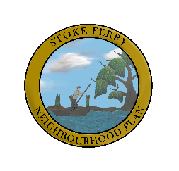
Stoke Ferry NP Latest News ~ Sept 28 2020
Despite it being a summer of CORONA-19 difficulties we have almost completed the Stage 2 of our Consultation Process. This involved door-to-door delivery and collection of our NP survey as well as promoting the completion of the form on-line. We have had further input from landowners, businesses, community and arts organisations across our Parish.
Many thanks to all those who completed the paper/online survey and to all those organisations who responded to our phone survey. We are having a virtual meeting in October to analyse the data that has been collected and feeding it into our Parish Neighbourhood Plan. Details will be posted on this page by the end of October.
We have also been out and about in the Village completing the Character Assessment of the different areas of Stoke Ferry. We have completed most of the different areas in our Parish and will compile the results asap.
Funding: We have been successful in our application for the second round of funding from Locality. We have been successful in our applications for two Technical Support Grants to carry out a 'Housing Needs Assessment' and 'Design Statement'.
Phew...it's been quite a busy summer!
Thanks for visiting

