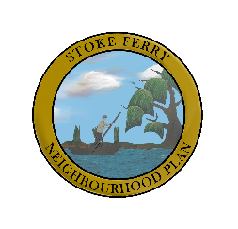
Stoke Ferry NP Latest News ~ July 14 2020
We are currently completing Stage 2 of our Consultation Process; this time with businesses, community and arts organisations across our Parish.
​We are also out and about in the Village completing the Character Assessment of the different areas of Stoke Ferry. We have completed most of the Conservation Areas and are now concentrating on other parts of the built environment.
​Funding: We have applied for the second round of funding from Locality and also for a grant to carry out a Housing Needs Assessment.
​We also thought that you'd like the graphic (below) which gives an update on Neighbourhood Plan progress across the country.
​Thanks for visiting

